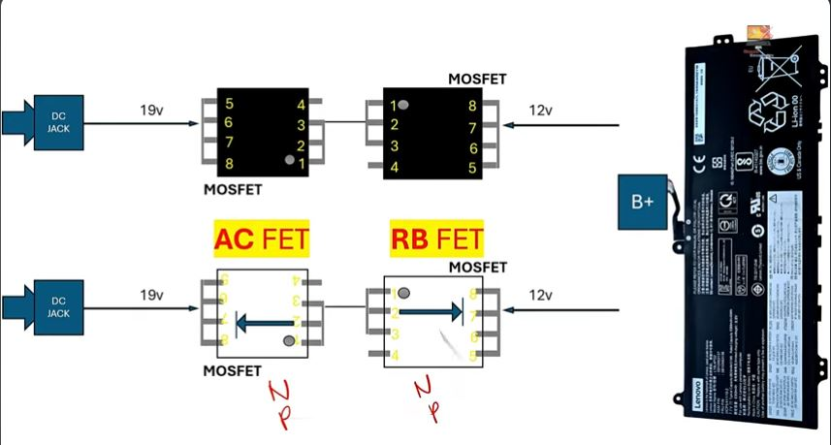

VIN section + Battery section ka core concept

1️⃣ Concept – AC FET aur RB FET kya hote hain?
Laptop me 2 main power sources hote hain:
- Adapter (19V)
- Battery (≈11–12V)
In dono ko direct jod nahi sakte, isliye 2 MOSFET lagte hain:
👉 AC FET
👉 RB FET (Reverse Battery FET)

2️⃣ Short Definition
- AC FET → Adapter se aane wali power ko control karta hai
- RB FET → Battery se aane wali power ko control karta hai
- Dono milkar OR-gate jaisa kaam karte hain (ek time par ek hi source)

3️⃣ Working (Image ke hisaab se)

🔹 Adapter laga hua hai

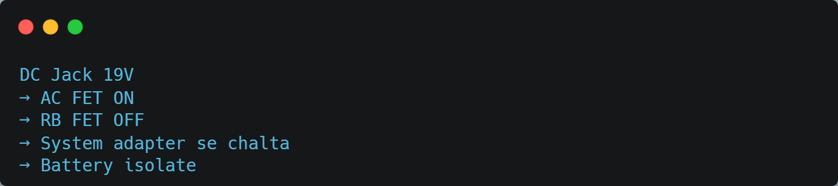
🔹 Adapter hata diya
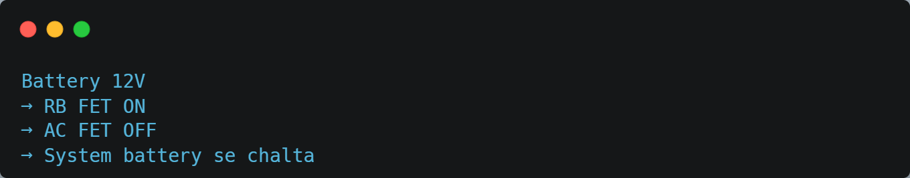

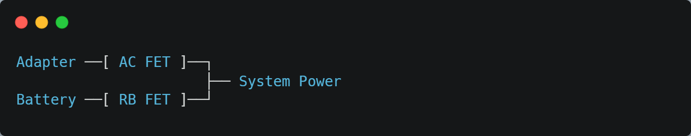

✔ AC FET = Adapter ka gatekeeper
✔ RB FET = Battery ka gatekeeper
✔ Ek time par sirf ek source active
✔ Laptop safe + stable rehta hai

AC FET
Full Form: Adapter Control FET
(ya AC Adapter FET)

🔹 RB FET
Full Form: Reverse Battery FET

